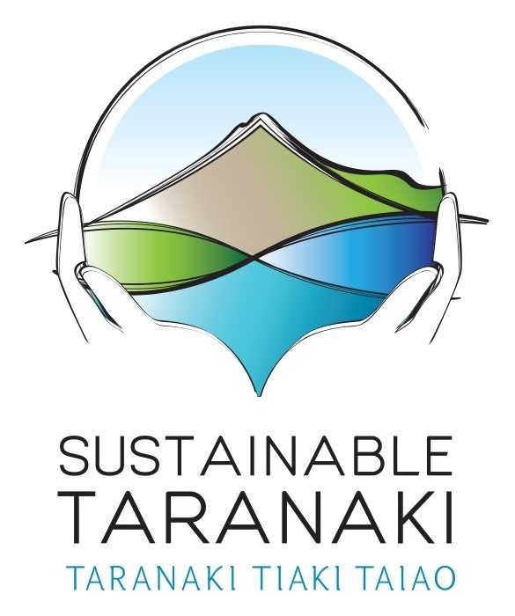
Taranaki Environmental Education Trust (TEET) operating as Sustainable Taranaki (ST) - Taranaki Tiaki Taiao
Bullying and Harassment Policy and Procedure

1. Introduction

ST is committed to maintaining a positive working environment and culture, where diversity is appreciated, and all people are respected and valued. ST regards discrimination, bullying or harassment, of any kind, as unacceptable. This applies whether this behaviour comes from, or is directed at, an employee, contractor, consultant, customer or a visitor to ST (“our people”). We expect all our people to model appropriate standards of conduct and report any breaches. If possible, behaviour can be adjusted and the working relationship can be repaired. We have processes in place to manage breaches if they occur.

NB: Employee, staff, or employment relations, etc. here applies to any and all relationships between ST and those that provide services, whether they be employees, contractors, volunteers or other (“our people”).

2. Why we have this policy?
This policy seeks to avoid undesirable behaviours, as they can be detrimental to both the health of the affected employee/s and business productivity. In addition, undesirable behaviours in the workplace can constitute a work-related hazard, which ST has a legislative duty to manage.

ST’s obligation to be a “good employer” is to ensure “freedom from harassment and discrimination in the workplace”, and establish specific responsibilities for all our people to “not discriminate against or harass any colleague or customer…”.

3. Who this policy applies to
This policy and the guidelines which support its application apply to all ST employees and independent contracted individuals (referred to as “all staff” or “a staff member”, or “our people”).

The policy covers behaviours that may occur in the workplace, between work associates, during work events (such as a conference or training) and outside the workplace if it is in the context of the employment relationship or affects the workplace.

4. Definitions - harassment, bullying & discrimination
In this policy, discrimination and harassment have the definitions as set out in the Human Rights Act 1993 and the Employment Relations Act 2000, which are summarised below. The bullying definition is from WorkSafe NZ’s definition in their best practice guidelines (2014).

4.1. Discrimination: Where a person is disadvantaged on the grounds of gender, marital status, religious belief, ethical belief, colour, race, ethnic or national origins, disability, age, political opinion, employment status, family status or sexual orientation.

4.2. Harassment: Where a person is subjected to repeated inappropriate behaviour, direct or indirect, whether verbal, physical or otherwise, at the place of work and/or in the course of employment that:
• expresses hostility against or intimidates or ridicules them, and/or
• is unwanted, hurtful and offensive to the employee, and affects their performance or job satisfaction.
This is most commonly sexual or racial harassment (both specifically defined in ERA) but can include other forms.

4.3. Bullying: Unreasonable and repeated behaviour towards a person or group that creates a health and safety risk.
• Repeated behaviour is persistent and can include a range of actions.
• Unreasonable behaviour covers actions which a reasonable person wouldn’t do in a similar circumstance, including victimising, humiliating, intimidating or threatening a person. A single incident isn’t considered bullying but can escalate if ignored.

Bullying includes cyberbullying - where technology (internet, mobile phone, digital camera etc.) is used as a means to bully. The Harmful Digital Communications Act (2015) sets out serious consequences if electronic communications are used with the intent to cause harm, and includes 10 communication principles, many of which relate specifically to harassing, discriminatory or bullying behaviour.
NOTE: These terms are not mutually exclusive, so harassment and discrimination can be part of bullying.

5. Prevention and Management
This policy, and the guidelines which support its application, look to ensure all staff:
• understand ST’s commitment to a positive workplace and that unacceptable
behaviour will not be tolerated under any circumstances
• have access to the information and resources they need to better understand
harassment, bullying and discrimination
• know how to raise a concern/complaint, and the options available to them.

Workers agree to:
- tell their manager/s if they experience or see any bullying behaviours – if the manager is the person behaving in a bullying manner, then advise the Trustee responsible for Whistle-blowing (see Whistle-blowing policy statement)
- try low-key solutions (e.g.: talking to the person initially (if safe to do so))
- follow the company’s informal or formal processes when making a complaint
- keep an eye out for other people, providing support when seeing a person being isolated or experiencing reprisals
- accept that perceptions of bullying may need to be negotiated.

ST agrees to:
- ensure workers have clarity on what their roles entail
- intervene early to call out and deal with any unreasonable behaviour before it escalates
- record and investigate complaints fairly and in line with the business or undertakings policies and processes
- look for informal solutions before escalating an issue to higher levels (e.g.: mediation or investigation) where appropriate.

6. Making and Managing Complaints

You can make a complaint in writing or verbally to the direct manager or to the Operations Team Leader. If you do not feel comfortable doing either of these things you may make a complaint to the Trustees (note above, re: Whistle-blowing).

When dealing with an allegation of bullying ST will:
- treat all matters seriously, promptly and impartially which may include an internal or external investigation
- ensure neither the person who complained nor the alleged bully are victimised
- support all parties involved
- find appropriate remedies and consequences for confirmed bullying as well as false reports
- communicate the process and its outcome
- ensure confidentiality
- use the principles of natural justice and both parties are treated fairly, and respected and supported through the process.
- keep good documentation
- have specialist external advisors available to help.

There is a preference for appropriately tailored solutions. For example, exploring low-key solutions before formal actions are taken if this is appropriate, or proceeding straight to a formal investigation if necessary.

7. Disciplinary Action
If an allegation of harassment, bullying or discrimination is proven through a formal employment investigation process, the behaviour may amount to misconduct or serious misconduct, and could result in disciplinary action up to and including summary dismissal.

ST would not expect any negative consequence for a staff member making a complaint (known as victimisation). However, if a staff member raises a complaint that is found to be fictitious or vexatious, ST may take disciplinary action against them.

