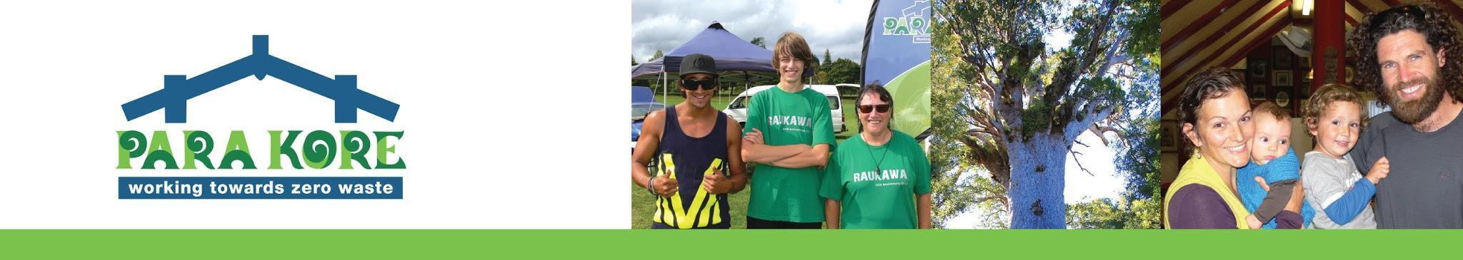POL17_FOOD POLICY and GUIDELINES FOR CATERERS
When we provide food, as much as possible we make sure we know the whakapapa of our kai. We prefer our hui to be vegetarian.
As far as possible we support locally grown and harvested kai. We support food without packaging/zero waste. We prefer organic kai.
We’d like our Para Kore hui to serve lots of vegetables and fruit, Māori kai/wild kai, butter cream and whole raw milk, traditional lacto-fermented foods and drinks.
*If someone provides us with their own meat, then we’ll serve it. This could also include organ meats, such as liver, pasture-fed meats, dairy and eggs, wild fish, shellfish, fish roe and homemade bone broth.
Overriding all of the above is the need to be respectful to those providing catering. Therefore we will display manaakitanga and gratitude towards our caterers and make allowances for what they would like to serve.

Guidelines for Para Kore Catering

Kia ora Caterers
We appreciate your reading and taking the following into consideration. Our kaupapa is about reducing waste and we are also mindful of the whakapapa of kai. For these reasons we’d like to explain what we prefer:

- leftover food from one meal to be used in the next meal for the purpose of reducing food waste
- As little packaging as possible, as little bought packaged food as possible
- Therefore, we like things made from scratch such as dips, baking, cakes, slices, bread that way there is less plastic waste
- locally produced food as much as possible
- spray free fruit and vegetables if possible
- Please use reusable bags when grocery shopping - also for fruit and veges - we can provide this if you haven’t got any - please ask
- Buying as much ‘nude’ food as possible, food that doesn’t come packaged up but just as is. You will need reusable bags or cardboard boxes though to put it in!
- Mostly vegetarian food
- No caged chicken or caged pig meat please
- No caged chook eggs please
- Please separate cans, plastic, glass recycling, cardboard and soft plastic for recycling
- All recyclables have to be clean. Soft Plastic Recycling has to be clean and dry.

Food Waste Audit (only applicable in certain cases)
We would really appreciate it if there could be three different buckets for food waste
- Food gone off - gone bad
- Food prep scraps, i.e. potato peelings, apple cores, banana skins, trimmings etc
- Plate leftover scrapings
- Food cooked but not eaten (this category is good food, that didn’t get eaten, might not be thrown out as such, might not be in a bucket) This food will hopefully be used in the next meal.

Please note that on the last day we will hold a waste check and we hope to have as little as possible going to landfill.

We are really appreciative of any of these guidelines that you are able to follow to help us uphold our Para Kore values of kaitiakitanga. If you need any support in meeting our policy and guidelines please get in touch with us.

Mauri Ora!

